**CCW UI Flow---AngularJS**

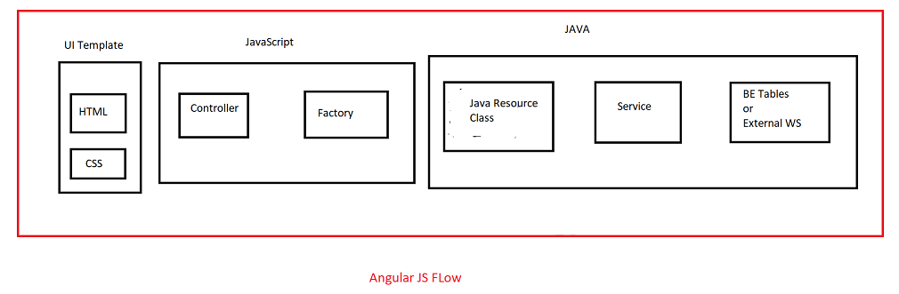

UI contains Header Part

1. Header part contains HTML template

2. Template will use whatever variable, methods/JS methods/JS functions are there in the template

3. Those JS functions will be defined in the controller

4. That Controller whatever data being displayed here in the Header Part/template like DealID,Quote Number(Quote Object ID) and all they get it from this Factory File/Javascript file



5. Factory File is s service file

6. This Factory file will call the Java Resource Class through rest API’s(rest web services)

For example if you see

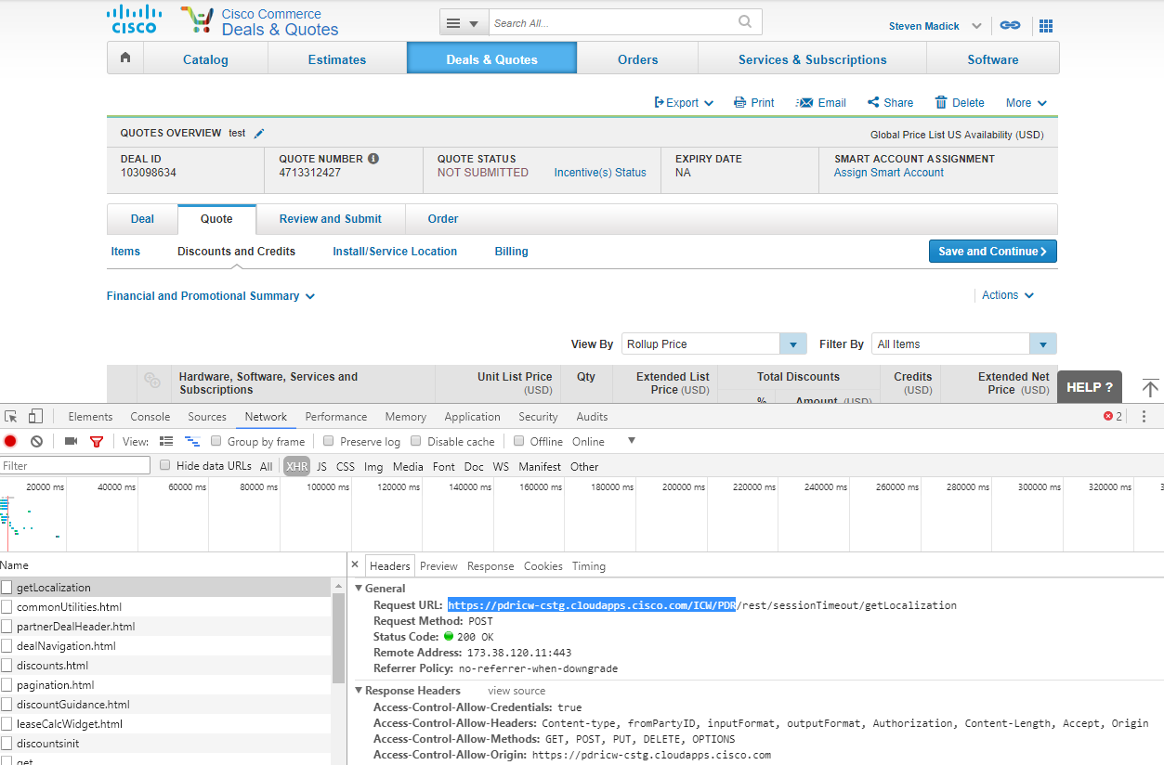

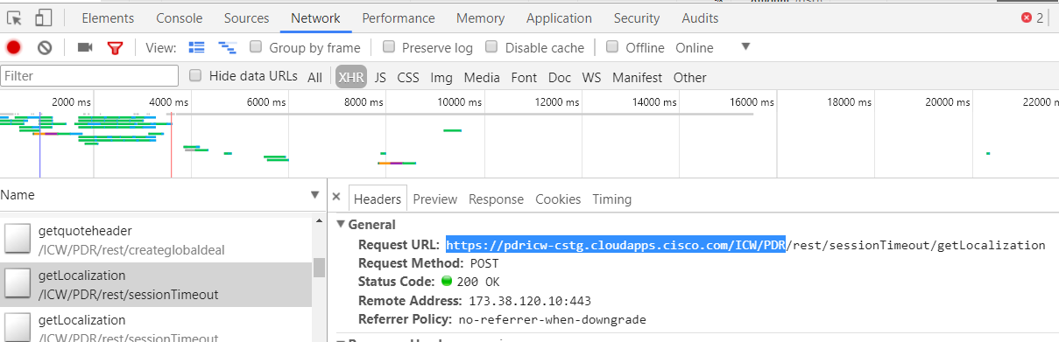

So that is host URL <https://pdricw-cstg.cloudapps.cisco.com/ICW/PDR/>

7. Java Resource class will call the Service Class

8. Service class finally get the data either from BE tables using Hibernate or through External Web services

Example:

Suppose if we want to know how they calculated Extended Net price for this product

1.Inspect on the “Extended Net Price”(19000)

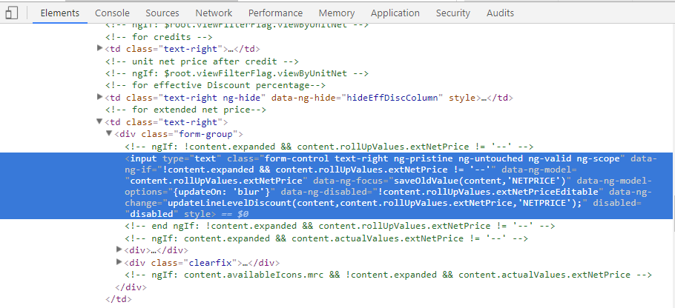

So first have to find out what is the template for that goto—Network Tab—XHR

majorDiscountItems.html will be the template

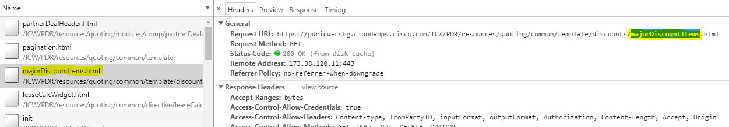

Even then if we are not sure we can inspect on the Extended Net Price “19000”,in Elements Tab we find the function like “updateLineLevelDiscount” and search for it in eclipse workspace in war(enterprisequotingui)

Click ctrl+H🡪Go to File search

**Containing Text**: updateLineLevelDiscount

**File name patterns**:*.html

It will show the method is in which html file so that was the template.so we can open that and observe where it is by seeing packages

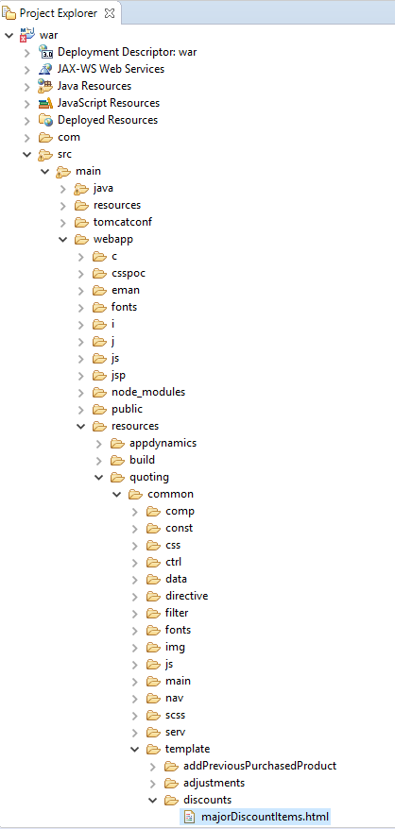

So usually controller and factory files also will be here like if we goto quoting🡪modules>and search any folder that folder conatains:

a.template

b.controller

c.factory

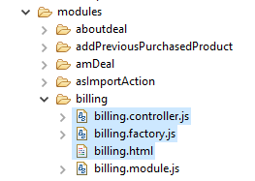

if we see in factory file i.e billing.factory that will call Java Resource class

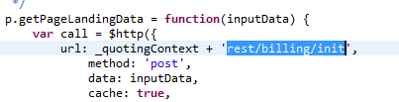

So now to know the controller and factory files for this template “majorDiscountItems.html”

Note:

1.Template is usually used in Controller sometimes in directive also

2.And we have factory file

3.Factory file will call Java Resource class

Seearch for majorDiscountItems.js by clicking ctrl+H,then it will show the file “renderDiscountItemComp.js” in that we will have the controller

Controller: “discountMajorLinesCtrl”>it will be there in

**Modules🡪discountsTab🡪 discountMajorLinesCtrl.js**

Now in this Controller search for JS function “updateLineLevelDiscount()” which we saw in Elements Tab when we inspect that Extended Net price

majorDiscountItems.html is a template which will display the values like Extended Net Price

Here “renderDiscountItem” will be the directive

In “renderDiscountItemComp.js” there is a directive called “renderDiscountItem”.A directive can de used in different ways in html

1. Directive can be a tag element

< render-discount-item ></ render-discount-item >

2. Directive can be attribute

<body render-discount-item<</body>

So these are the ways to call the angular directives

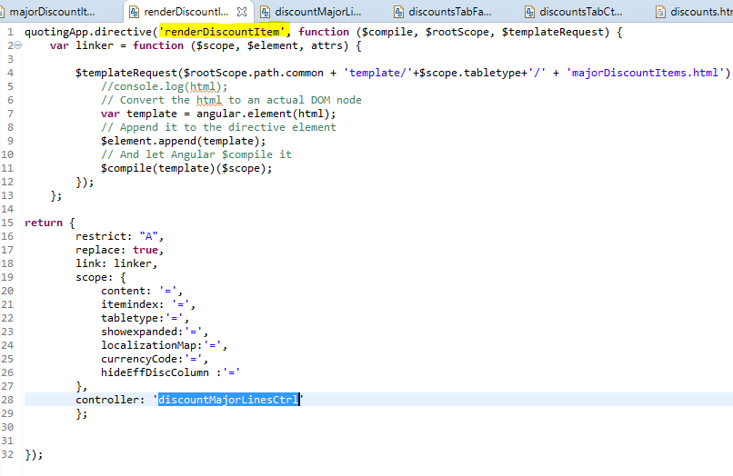

In above scope variables like content,itemIndex,tableType variables contain data that will be passed to directive “renderDiscountItem” which will display the data finally

Now if we inspect on “Extended Net Price and observe the

data-ng-model="content.rollUpValues.extNetPrice"

so values will be in this scope variable “content”,you just have to see where they are using this directive and what data we have in this “content”(what data we are passing into this content)

let us check this directive in “discounts.html”

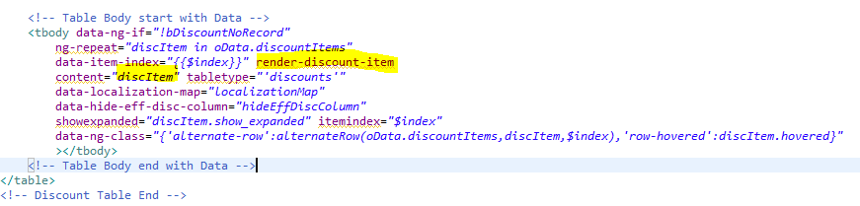

If we see they are passing “discItem”as a data to this “content”

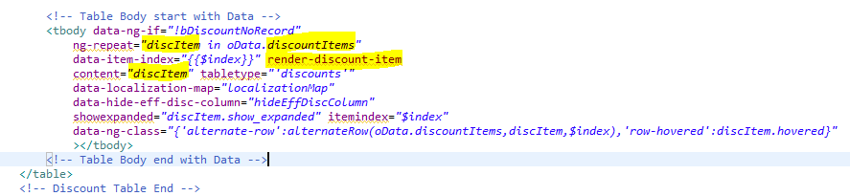

Here if we see “discItem” is “discountItems”

And “discounts.html” is again a template

In the modules “discountsTab” folder,the controllers will be in same folder

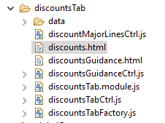

So “discountsTabCtrl.js”will be the controller,if we see in this file they would have given this template somewhere

So “discountsTabCtrl.js”will be the controller for this “discounts.html”template

Search for the variable “oData.discountItems” in “discountsTabCtrl.js”

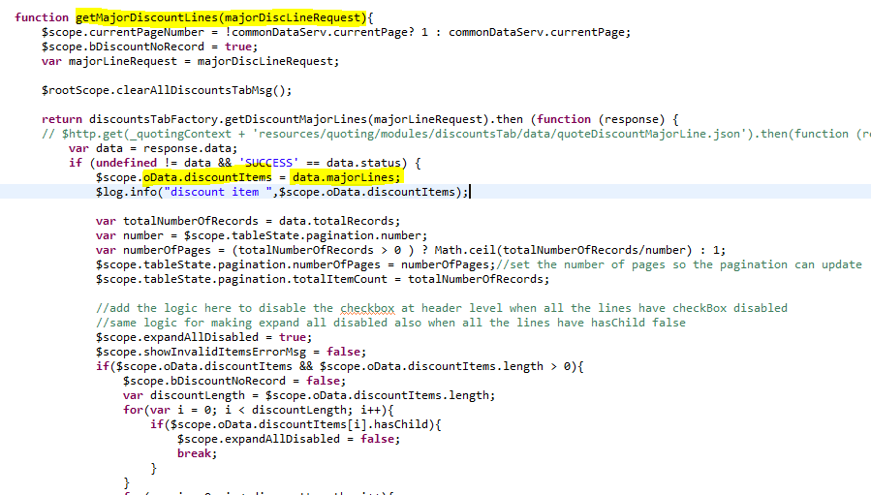

So if we observe above code, discountItems contains the data “data.majorLines”.So here

**function** getMajorDiscountLines (majorDiscLineRequest)

{

--main logic—

}

This will be the main function. This function gets all the data

So this function is calling some factory function like

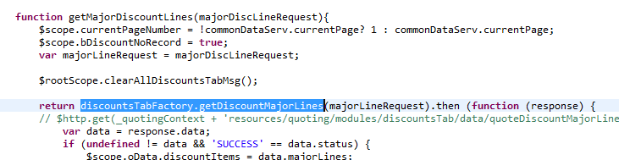

So search for that function “getDiscountMajorLines()” in the factory file called “discountsTabFactory.js”

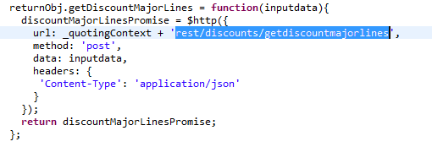

So this function is calling the REST API (this is calling this rest API i.e. “rest/discounts/getdiscountmajorlines”)

